To create a simple web app with Nodejs and Express.  
First we install Nodejs from internet:  
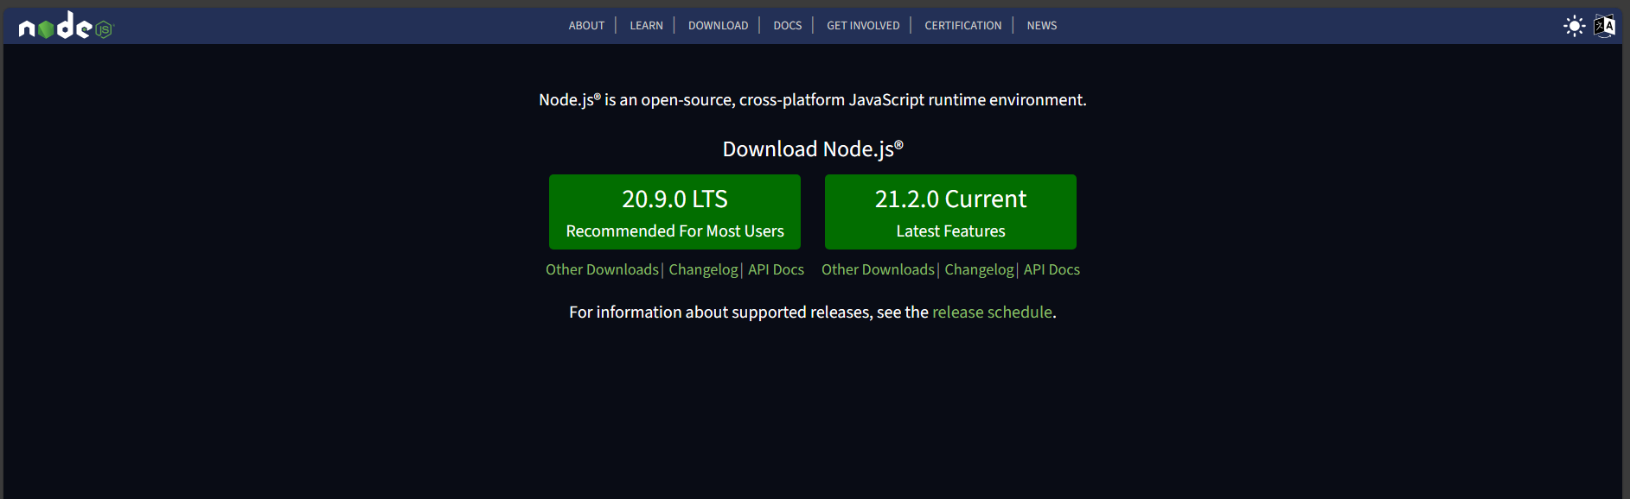  
  
Then do like instruction to setup it.

If it correctly installed we can test it on cmd like this:  
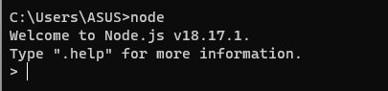

Then create a folder and install Express:  
  
  
If success it will be like this:

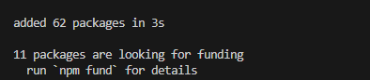

Then we create an app.js file and put some code in:

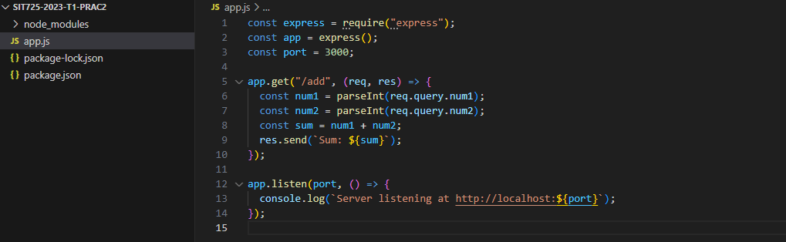

You can see we using express with port 3000 (basic common port)

And we have get method to add 2 number in /add path

First run node app.js to start the web server:  


Then go to localhost:3000 on any browser:

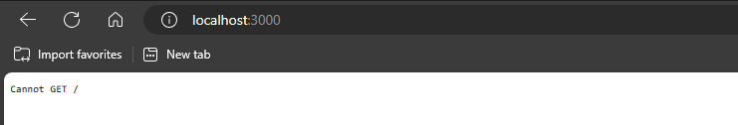

If this is correct it mean we haven’t create a get method for home page.

So add this line in the code:

app.get("/", (req, res) => {

  res.send("Hello World");

});

Now restart the server by click ctrl + c in terminal and run node app.js again.  
Then you can refresh the browser and see it has Hello World now

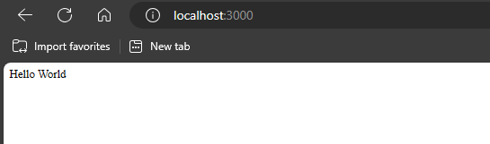

Now we also have the add 2 number in our web server:

app.get("/add", (req, res) => {

  const num1 = parseInt(req.query.num1);

  const num2 = parseInt(req.query.num2);

  const sum = num1 + num2;

  res.send(`Sum: ${sum}`);

});

To test it just go to this path on your browser:  
**<http://localhost:3000/add?num1=3&num2=4>**you can change num1 and num2 if you want, in this case the number 1 is 3 and number 2 is 4 so the result is 7

The result we have is here:

